Morphing Objects – Shape shifting technology

*Atibhav Mittal*

*CS 35L Spring 2016*

*University of California, Los Angeles*

**Abstract**

Some people say that Computers are the best invention of mankind. However, ever since the time they were introduced, there has been one thing that stays the same with computers – they remain static. Even though we use these machines to interact with other humans, these machines are unable to capture the dexterity of human movement. However, with shape shifting technology, it will soon be possible for us to interact physically with people who are far away from us. Shape-shifting technology has a variety of applications in variegated fields, and has the potential to change our world.

**Introduction**

Humans have used tools ever since records have been kept. For the hunter-gatherers, it was wooden spears, and for us, more sophisticated tools like Computers and Robots. Visionary individuals such as Sean Follmer and Ido Bachelet have recognized that there is a scope for improvement in the tools we use. Sean Follmer, a researched at Stanford University has invented an “inFORM Platform”, that uses linear actuators to imitate real life objects. Ido Bachelet, a researcher in Israel, is currently developing “Fluid Robots” that can be used to create a new kind of robot, which is resistant to damages and can easily reach narrow channels.

**Detailed Description**

I. InFORM Platform

The inFORM platform is one of the shape shifting technologies, which is currently being developed by Sean Follmer. This device is aptly called a platform, since it’s a platform of block like structures called linear actuators. These actuators are made out of long wooden blocks that work on a pin based system. When pressure is put on a block, the pin is activated and as a result, a message is sent across the inFORM platform. The way these work is that an object is placed on one of the platforms. The depression caused by these objects on the pin-linear actuator system leads to a simultaneous platform at some other place having a similar depression. Essentially, is happening here is that the object’s shape gets transmitted to the second platform. Such kind of platforms can be used to collaborate on architectural projects. As of today, architects have to carry/send blueprints via email and have to meet up in reality to build the platform together. However, with the inFORM platform interaction via platforms would be possible leading to collaboration without physically meeting up. Another great advantage of these platforms is that a variety of games can be played between two people with the inFORM platform. These platforms also add a “third-dimension” to the existing video chat that we have. A person on the other end can be of a video chat application like Skype could interact with his platform to essentially interact with another person’s platform, thereby adding a third-dimension to video chatting.

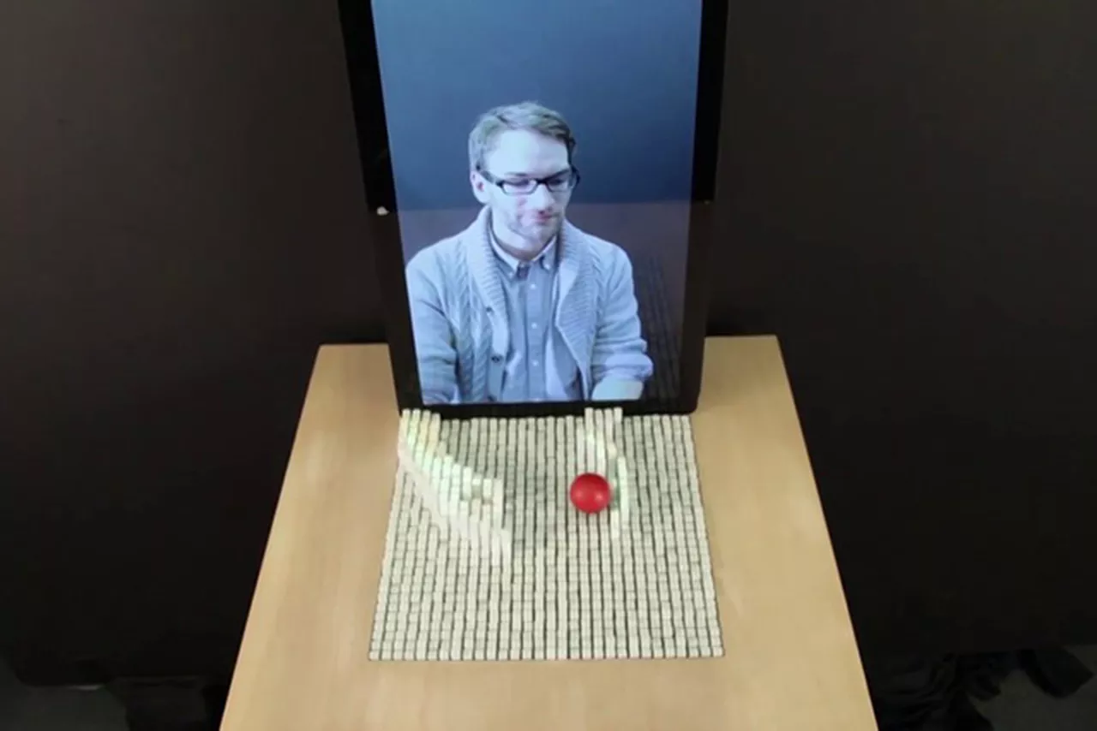

A demonstration of video chatting with the inFORM platform

The inFORM platform doesn’t always require physical contact to transmit messages. Through the use of a depth-sensing camera, like Xbox Kinect, users can transmit messages by making gestures in front of the camera.

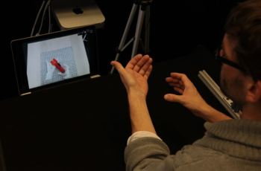

inFORM Platform with a depth sensing Camera[4]

In his TED talk, creator Sean Follmer illustrated another innovative use of this technology. He uses a wristband that morphs into a cellphone. Cellphones have been becoming thinner and sleeker over the past decade. However,

There is still a lot that needs to be done to make this technology actually useful to the general population. The linear actuators used are far away from simulating real-life objects. The pins are thick, which take away the ability of the blocks to describe objects exactly as they are. They are not able to capture the dexterity of human movements yet. However, researchers are working hard to make this technology useful for the masses.

II. Shape Shifting Fluid Robots

The shape shifting fluid robots are fluids based on non-Newtonian fluids. [2] They are essentially just tiny blobs of liquid. Most liquids, like water are Newtonian fluids, which essentially means that they have a constant viscosity. However, these robots due to their property of being made out of Non-Newtonian Fluids gives them an additional advantage. These robots have the ability to get to places that conventional robots have a tough time getting access to. For instance, these robots can access narrow crevices and cracks since they are fluids. Since they are essentially fluids, they are more resistant to scratches and physical damage as compared to a traditional robot made out of a solid, such as Aluminum or Steel. One of the most fascinating properties about these robots is that they have the ability to carry items that are 5 times their own weight. Additionally, these small blobs of non-Newtonian fluid can separate out into even smaller blobs and therefore can do additional tasks. Another amazing property of these blobs of liquids is that they have the ability to count (only up to 3). The way they count is by absorbing a substance called Aluminum Oxide. The way this works is that they get stiffer and stiffer as the concentration of Aluminum Oxide increases. Since this is a relatively new technology that is still being developed, there is a lot of scope for improvement. One of the main drawbacks of this technology is that it only works on sound-generating platforms. It can be triggered by remote means using electromagnetic radiation and other such waves, however there is still a certain threshold distance that we need to be in from the actual platform. Hence, the key area where we need to improve this technology is to make it work on any and all platforms.



Shape Shifting Fluid Robots [2]

**Results**

As we have seen from the above two emerging technologies, there is a lot of potential for these applications in a variety of fields, ranging from architecture to mechanics to simple day to day interaction. This is a relatively new technology and as listed above, they require a lot of improvement to actually simulate real-life objects (for the inFORM platform) and to make a universal platform (for the shape shifting fluid robots). According to “physicist and Big Think Blogger,” [3] Michio Kaku claimed that Shape-Shifting technology is one of the few futuristic revolutionary technologies that we can hope to see in our lifetime.

**References:**

1. "Shape-shifting Tech Will Change Work as We Know It." Sean Follmer:. N.p., n.d. Web. 02 June 2016.

2. "Researchers Are Developing Shape-Shifting Fluid Robots." Inside Science. N.p., 19 Feb. 2016. Web. 02 June 2016.

3. "Michio Kaku: Shape-Shifting Technology Is Coming." Big Think. N.p., 12 Oct. 2010. Web. 02 June 2016.

4. "MIT Demonstrates Shape-Shifting Technology Tools ENGINEERING.com."MIT Demonstrates Shape-Shifting Technology Tools ENGINEERING.com. N.p., n.d. Web. 03 June 2016.